SMS System - Database

💾 SMS System - Database Component
# Source: AI Source: Provided by: [Data Path: Persons Table -> ID Column: 1, Name_En Column: Motasem Essam] -> From: [Chatgpt (GPT‑5 Mini)] on [1/21/2026]
In an SMS system, the Database plays a critical role in storing, managing, and retrieving information necessary to send, receive, and track SMS messages.

📂 What Is It?
# Source: AI Source: Provided by: [Data Path: Persons Table -> ID Column: 1, Name_En Column: Motasem Essam] -> From: [Chatgpt (GPT‑5 Mini)] on [1/21/2026]
The SMS database is a structured storage system used by the SMS application or SMS gateway to:
- Store message logs
- Keep user profiles
- Save message templates
- Record delivery reports
- Handle message queuing (pending messages)

🧱 Key Data Stored:
# Source: AI Source: Provided by: [Data Path: Persons Table -> ID Column: 1, Name_En Column: Motasem Essam] -> From: [Chatgpt (GPT‑5 Mini)] on [1/21/2026]
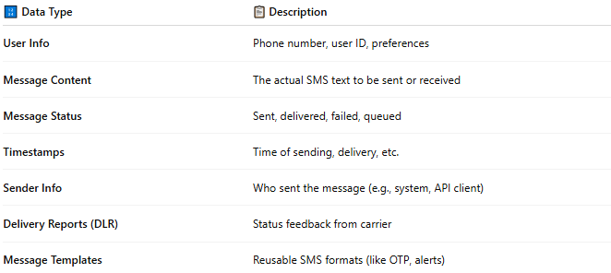

🔢 Data Type | 📋 Description
User Info | Phone number, user ID, preferences
Message Content | The actual SMS text to be sent or received
Message Status | Sent, delivered, failed, queued
Timestamps | Time of sending, delivery, etc.
Sender Info | Who sent the message (e.g., system, API client)
Delivery Reports (DLR) | Status feedback from carrier
Message Templates | Reusable SMS formats (like OTP, alerts)

🧰 Use Cases:
# Source: AI Source: Provided by: [Data Path: Persons Table -> ID Column: 1, Name_En Column: Motasem Essam] -> From: [Chatgpt (GPT‑5 Mini)] on [1/21/2026]
- Track sent/received messages
- Resend failed or delayed messages
- Generate Reports (e.g., delivery success rates)
- Log Activity for auditing and analytics
- Throttle or control sending limits per user/device

💡 Typical Technologies:
# Source: AI Source: Provided by: [Data Path: Persons Table -> ID Column: 1, Name_En Column: Motasem Essam] -> From: [Chatgpt (GPT‑5 Mini)] on [1/21/2026]
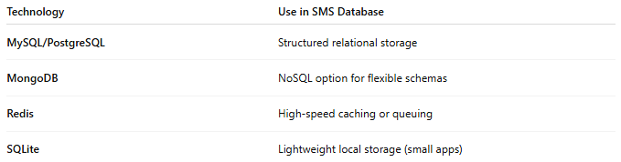

Technology | Use in SMS Database
MySQL/PostgreSQL | Structured relational storage
MongoDB | NoSQL option for flexible schemas
Redis | High-speed caching or queuing
SQLite | Lightweight local storage (small apps)

🔄 Example Workflow (Using Database):
# Source: AI Source: Provided by: [Data Path: Persons Table -> ID Column: 1, Name_En Column: Motasem Essam] -> From: [Chatgpt (GPT‑5 Mini)] on [1/21/2026]
- User requests OTP via app.
- System checks user info in the database.
- SMS is composed and saved to the “pending” queue.
- SMS gateway reads and sends the message.
- Delivery status returned → logged in the database.

